Mechanized Tactics
U.N.M.C.F mechanized units are reliable, valuable assets to the fight.
Mechanized units bring fast mobile fire power via tracked, wheeled, and or hover powered vehicles, and scout teams to integrate fires along with the infantry. Mechanized units can withstand engagements unaided by ground troops depending on disengage/displacement criteria.

Developing Battle Positions
Vehicles assigned to establish a defense, security, and or assault mission should utilize terrain in order to establish an effective battle position or BP. Typically the commander of the crew would use sloped terrain to where the crew can scan and observe over terrain, and be able to drive into a hot POS to engage a target, then drive back down into defilade.
This is recognized as being called a burm drill. Utilizing this allows crews to scan, engage, and report enemy positions while keeping their vehicle out of harm's way as best as possible.
Fluent communication between drivers, gunners, and or vehicle commanders are crucial to accomplish such a said task.
- Universal commands for the driver to drive out of defilade go into a hot POS would be “DRIVER UP” *driver drives into hot POS
- Universal command for driver to go back into defilade or cold POS would be “DRIVER DOWN!” *driver reverses into defilade or cold POS
Elements Of Fire Commands
There are four elements within a fire command.
- Alert
- Direction
- Description
- Range
- Execution
Alert- To notify the crew that a fire command is about to occur
Direction- Using terrain, TRP’S, and or the clock method, where the target is located.
Description- What type of target that is going to be engaged.
Range- Guesstimated distance.
Execution- When to fire, and how the gunner should engage.
The most rapid way of delivering a fire command is by just using description, and execution if situation dictates.
When issuing the execution order the vehicle commander can use orders such as, “FIRE!” *Gunner fires one round or burst, “FIRE AND ADJUST” *Gunner engages and adjust rounds until target is destroyed”
Fire command script
VC- “Gunner!”
VC- “Traverse right/left!”
VC- Enemy “Warthog in the open”
Gunner- “Identified!
VC- “Fire and adjust!”
Gunner- “ On the way!”

Vehicle/Weapon familiarization
UNSC 2558 Warthog
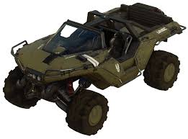
Typical infantry fighting vehicle may be equipped with
- M343A2 Chaingun 12.7x99mm AP or HEDP rounds.
- M555 Gauss Cannon 25x130mm AP rounds
- M80 Missile Launcher 80mm missile

M820 Scorpion

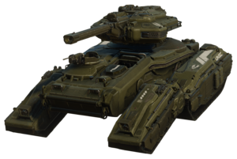
Main Battle tank equipped with
- M990 150mm smoothbore cannon
- Pintle mounted 12.7mm machine gun

Type 58 Wraith
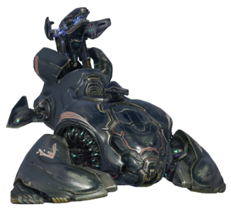

Mobile artillery piece equipped with
- Type 58 35mm directed energy mortar
- Fully automatic plasma cannon

*All and other UNMCF used vehicles should be generally known.

Utilizing Scouts
UNMCF mechanized units will typically operate with scout teams. Scouts should be replaced or patrol to terrain where they can scan, and report target positions so tat vehicles in BPs can remain hidden in defilade and only expose themselves when needed. Both scouts and crews should know the fundamentals of reconnaissance while operating and attempting to integrate fires.
Scouts should lure enemy into the fields of fire of vehicles or funneling terrain to establish fire superiority while working with vehicles in order to vanquish the enemy.
Scout teams may integrate fires by using call for fire, establishing LP/OPs near within the max effective range of vehicles in BPs, and providing support by fire on enemy targets.
Scouts may be used to close in with enemy structures during raid operations, and provide security to flanks of BPs.

Roles Of Drivers
The driver billet is tasked with scanning, and maneuvering a vehicle platform on the battlefield and providing a stable platform for the gunner to engage targets accurately. The driver is as equally as important to the survivability of the crew as the gunner.

Roles Of Gunners
The gunner billet is tasked with scanning, and employing the given vehicle platforms weapon system to engage and destroy the enemy. The gunner is as equally as important to the survivability of the crew as the driver.

Roles Of Vehicle Commanders
The vehicle commander or VC is tasked with scanning, and commanding the actions of the driver and gunner. The VC is equally as important to the survivability of the crew as the gunner, and driver.

